Application for Road & Footpath Occupation Permit

Procedures and Instructions

Roads Act 1993 – NSW Legislation.
Road Occupancy Permit Roads Act 1993 – Section 138 Works and Structures.

Applications will be received by email, post or over the counter. The majority of applications will be received via email.

- Once received Records will TRIM and forward to Mark Biondich (MB), Subdivision and Development Engineer, Engineering Department for assessment, determination of fees and notes will be added in TRIM for Customer Services (CS).
- The TRIM task will be allocated to Amy Bowles (AB), Customer Service Coordinator and then allocated to a member of the CS for processing.
- CS will check the application and call the applicant for payment details. Visa card or Mastercard payment will be accepted over the phone.
- Once payment has been received the CS officer will enter the information into Authority based on the information detailed in the application and notes in TRIM.
- Fees will be raised and then the memo to cashiers will be generated and the payments receipted by cashiers.
- Once payments has been receipted, please note receipt details, application number and complete details in the Office Use Only section, write TRIM – MB in the top right hand corner and forward to Records. Alternatively, this information can be added in TRIM by adding notes, relating the record numbers and then reassign the TRIM task to MB.

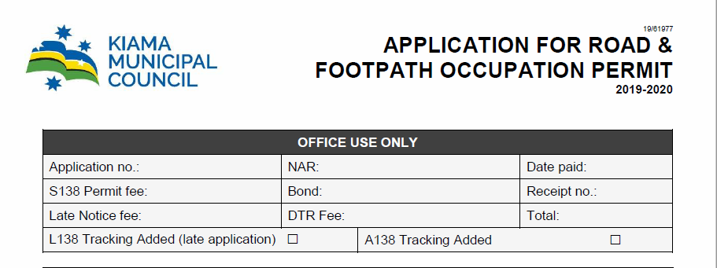

How to access the Register in Authority

Authority
Sitemap Engineering Road Occupation & Filming Register (doc type 202)
To create a new Register entry use the Road Occupation & Filming Register Entry
To update an existing Register entry use the Road Occupation & Filming Register Update.

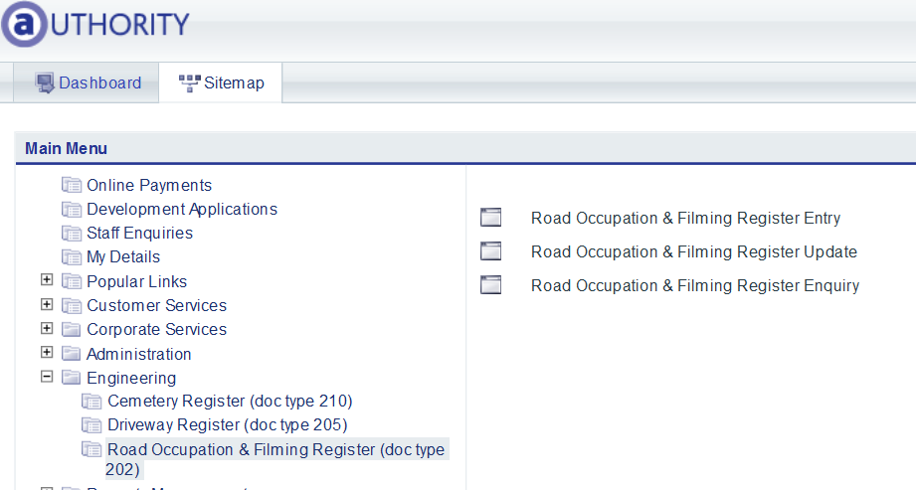

How to create a new Register entry

Road Occupancy & Filming Register Entry program
There are three tabs in this screen: Register Details, Additional Details and Browse.

In the Register Details select Add, or use the A key.

Tab or Enter through the fields to the Precis field and type in the description of works, as described on the application form eg; temporary road closure at 11 Manning Street Kiama for construction of footpath.

Tab to the Parcel and add the parcel number. Check parcel address details. As areas within a road reserve do not have a parcel ID; for road openings: search for and select the property directly adjacent to where the works are being undertaken, consistent with how a CRM is recorded for any issues within a road reserve. Only one main parcel is to be recorded if the works cover a length of the road or various parcels of land.

Tab to the Applicant and add the applicant details or search for the applicant details and then add the applicant details.

Tab through this screen and note the system will automatically add the details. Tab to the Additional Details tab and select the following:

- Permit Type
- Bond Type
- Film Risk Assmt (not applicable as this only relates to a Film Permit)
- PL Insurance
- Permit From and Permit To
- Traffic Plan

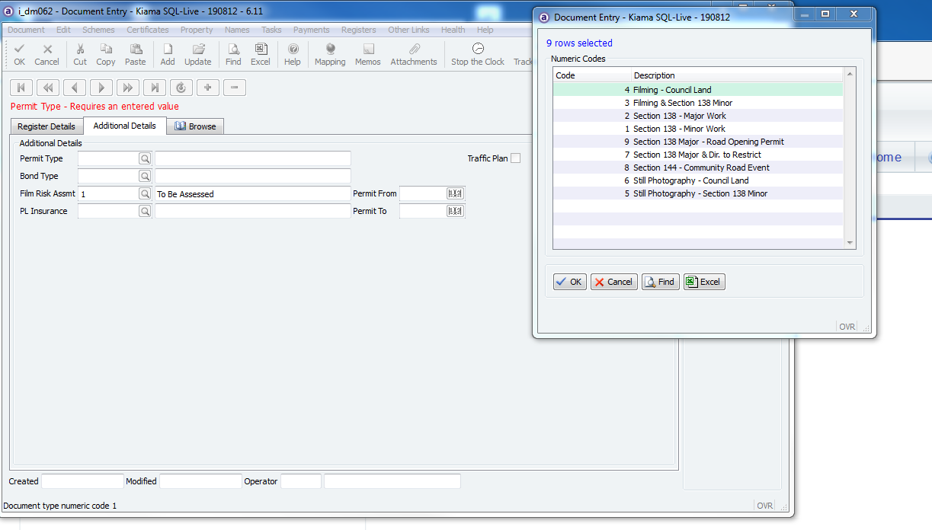

OK or F12 to confirm and note the new register number created for the register.

Raising fees for the application

Now that the application has been created we need to raise fees against it and generate a memo to cashiers template for the cashiers to complete the receipting.

Go to the Payments drop down list in the menu bar across the top of the screen.

From the Payment Request Entry program (i_dm078) select Update and click the curser into the first line in the Type field. From the drop down list select the appropriate payment types, one by one, until you have raised all appropriate fees relevant to the application.

Please ensure that you only select from the appropriate fees that are listed at the top of the Application Fee Type dropdown list - A800, A801, A802 and A803. All fees applicable to road occupation applications have a default fee set against them so you will not have to do any fees calculations from the Fees and Charges.

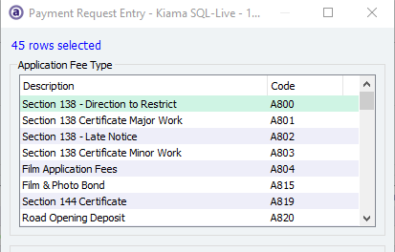

Please do not use the S138 Road and Occupy fees located further down the drop down list - DA32 and DA33.

Once all fees have been added select OK or use the F12 key to save.

Adding a tracking action

Go to the tracking icon and add a tracking action A138. This will generate a notification to MB. If the application is urgent, please add the additional tracking action L138.

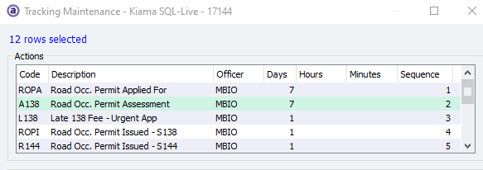

Once tracking has been added select OK or use the F12 key to save.

Memo to cashiers template

Select the Attachments button across the top of the screen.

This will open a program screen titled “Associated documents for document number 202.22020.001” (program ID i_al123) and then select the Write Letter button.

Select the applicant in the available name links screen then select the Include button at the bottom of that screen and then select OK.

This will open a new program screen called Attachment Central where you can select the Template you wish to generate. Application for Permit to Film and S138 Application – Memo to Cashiers.

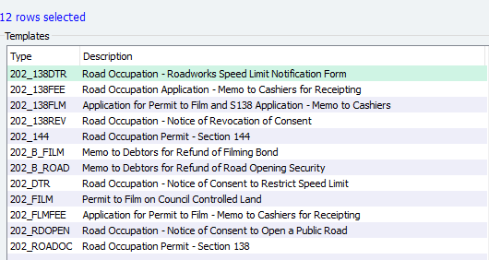

Click on the white arrow in the blue circle at the top centre of this screen. This places your selected Template over into the right side window pane of that screen. Select the OK button to run the Template.

You will be prompted with a Process window select Yes to process the Template. You will now be prompted with a Print Documents window, select No to print document. In the Variable Replacement window where it will prompt you to type in the payee name and address details for receipting.

After typing in the payee name and address and selecting OK the Template will continue to generate and then close as it is sent to the printer and saved into TRIM. Alternatively, this template can be emailed from TRIM by using the TRIM email icon.

UPDATE TITLE IN TRIM

Update the title in TRIM to reflect the Authority registration number, Application for Road & Footpath Occupation Permit – address – applicant name.

Container – CY18-08

Alternative Container – if related to a DA

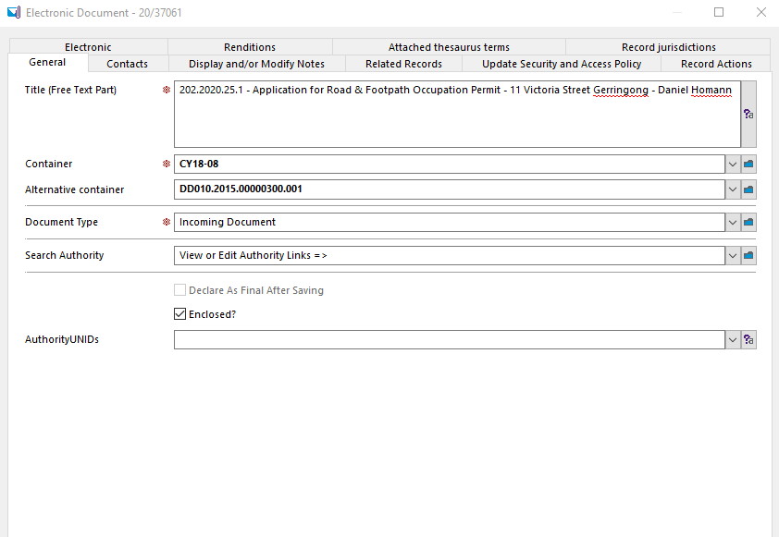

Connect the document to the Authority Register by searching the module and choosing Road Occupation and Filming and then click on Add Link and OK.
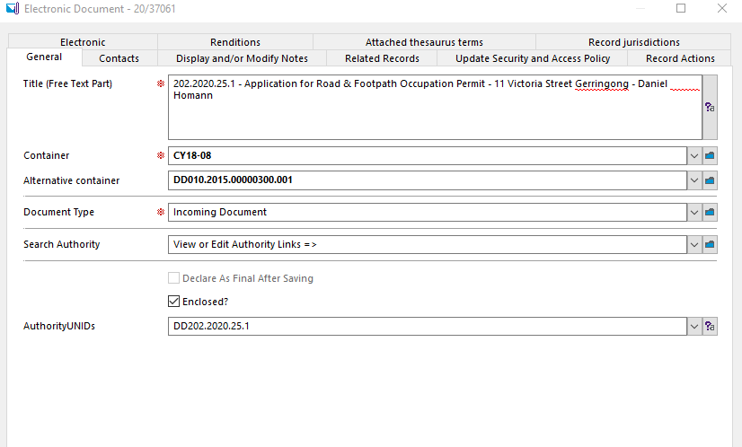

CASHIER - RECEIPTING

- Cashiers are to use Code 202 and the account is to be the application reference number. Any fees raised against this application and currently unpaid will present on the screen for processing.
- Complete the receipt entry process and attach the receipt details onto the memo. There is only one memo; customer copy memo.
- Post or email the receipt to the applicant/payee.
- Note receipt details, application number and complete details in the Office Use Only section, write TRIM – MB in the top right hand corner and forward to Records. Alternatively, this information can be added in TRIM by adding notes, relating the record numbers and then reassign the TRIM task to MB.

